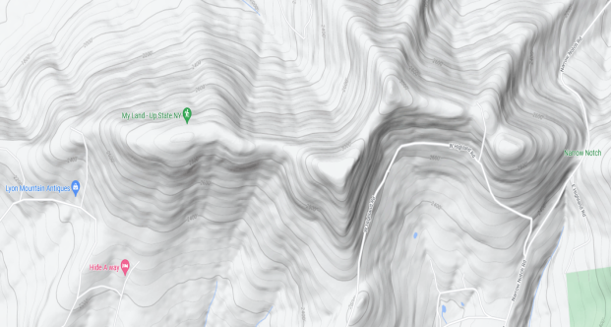LYON MOUNTAIN ROAD ASSOCIATION

PO BOX 151

HOBART, NY 13788

Land Owner Date May 15, 2022

RE: Information

Dear Fellow Landowner,

I’d like to introduce you to the road association. We realize that there has been a lot of interest in obtaining property in the Catskill Region, and Lyon Mountain has become very popular because of the privacy and vast opportunity for activities that it offers. More owners are interested in improving their property every day and we appreciate that.

We would like to improve the availability of information to all the owners on the mountain. We have taken the time to obtain maps and ownership information in order to correspond with everyone. As you know in this day and age, regular mail is basically obsolete. We would like to become a little more technology driven and update the method of communication.

Therefore, we are requesting that everyone submit an Email Address and Telephone Number so that we can keep in touch. We feel that in the future with cooperation from the owners that we can provide a possible Website that will offer general information, photographs, emergency information, and a Forum for open communication. Any information we gather is strictly for the sole purpose of communication with the mountain community.

We hope that everyone will participate in the program. The road has deteriorated substantially and needs attention. Obviously the new owners and the long time owners feel that there is value in owning property. The condition of the road greatly increases that value. We’ve collected enough in the past to supply about 15 loads of stone. These loads will provide repair for approximately 30 to 50% of the absolutely necessary repairs. In the past we requested $200 per property. Once a substantial majority of owners participate we can discuss the resources and contributions along with annual reports of progress. All owners will have the opportunity to input their thoughts on future repairs and improvements.

We look forward to you participation and response to this letter. Please provide you contact information through email to: [lyonmountainroadassoc@verizon.net](about:blank). You can call Peter Shervanick @ 917-414-7724

Thanks for your attention.

Vincent Mazzilli, Peter Shervanick, Willie Gonzales, Melvin Maisonave

Lyon Mountain Road Assoc