**Oklahoma Association for Pupil Transportation  
Regular Board Meeting Minutes**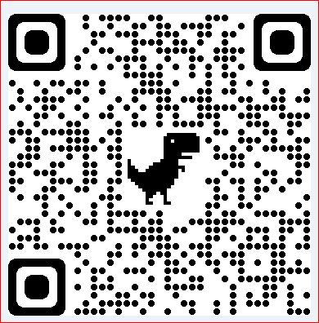

**Wednesday – January 12, 2022**

**Bixby, Oklahoma 10:00am**

1. **Call to order 10:00am : LeeAnn**
2. **Roll Call of Board and Leadership Team : Christy**

**Board: Leadership Team:**

President: **LeeAnn Millan** - Present Dept of Education: **Mat Luse** - Absent

Past President: **Tammy Bowler -** Present Dept of Education: **Kim Hale** - Absent

President Elect: **Erich Anderson -** Present Dept of Public Safety: **(Unknown at this time)**

Treasure: **Donnie Ryan** - Present **Billy Whittenburg** - Absent

Secretary: **Christy Clemons** - Present **Janiece Cress** - Absent

Communications: **Orville Burks** - Present **Kevin Means** - Absent

SW Director: **Jay Hunt** - Present **Chandria Youngblood**  - Absent

NW Director: **Chuck Lawson** - Absent **Rhonda Paulus** - Absent

NE Director: **Randy Empting** - Randy **Joanne Montgomery** - Absent

SE Director: **Kevin Winn** - Present **Charles Gordon** - Absent

Tulsa Metro: **James McNabb** - Present

OKC Metro: **Robert Feinberg** - Present

Vendor Director: **Dan Miller** - Present

1. **Recognition of Online Attendees:** _____________________________________________________
2. **Recognition of Guests:**_____________________________________________________
3. **Reading and approval of November, 2021 Regular Meeting minutes: No new minutes to approve**

*Motion to Approve / Not Approve / Table 1st: 2nd:*

1. **SDE updates**: Matt Luse & Kim Hale -
2. **DPS updates**: (?)
   1. CDL Testing “Under the hood” Waiver
3. **Communication Director :** Orville
   1. Phone
   2. Online/website
   3. Smart Horizons
4. **Financial Report:** Donnie Ryan
5. **Discussion and possible motion to approve, not approve, or table the Encumbrance and/or Payments the Following Donnie Ryan**

* *NAPT Class $2200*
* *NAPT Books $1059*
* *NAPT Class Pins $625*
* *Kay Francis $5500*

*Motion to Approve / Not Approve / Table 1st: Erich Anderson 2nd: Orville - Passed*

1. **Officers reports of Area Directors** 
   1. NW Director-Chuck Lawson - Not present
   2. NE Director-Randy Empting- Not present
   3. SW Director-Jay Hunt - Nothing new to report
   4. SE Director- Kevin Winn- Short on drivers, recommending not doing waiver
   5. Tulsa Metro Director-James McNabb- Nothing new to report
   6. OKC Metro Director-Robert Feinberg - Compiled metro list of directors, canceled lunch with directors
   7. Vendor Director-Dan Miller- Continuing to work with vendors
2. **2022 Committee Assignments: Committee will meet separately.** 
   1. Conference Awards and Pins

*James, Christy, LeeAnn*

* 1. Add Transportation Support Employee of the Year Award

1st: Robert, 2nd: Donnie - Passed

* 1. Nominations and Election :
     1. Positions for Vote __President Elect__________________
     2. Positions for Vote __NE Metro Director_____________________
     3. Positions for Vote __Tulsa Metro Director_____________________

*Robert, Orville, LeeAnn*

* 1. Mechanics Day

*Jay, Chuck (???) Mechanics agenda? )*

* *Will start reaching out for ideas, training, etc.*
  1. Conference Topics and Speakers

*LeeAnn, Orville, Tammy*

* Looking at training in Homeland Security training, student behavior, special need and transporting medication, transportation finance, Director one-on-one roundtable
  1. Conference Catering and Logistics

*Jay, LeeAnn*

* Looking at moving vendor lunch to hotel
* Board to review agenda and discussed possible changes
  1. Vendor Show and Buses

*Dan, Erich, Kevin*

* *Looking at locations, pricing*
  1. Golf Tournament

*Tammy, Orville*

* *No updates*
  1. Bylaws Review and Recommendations

*Chuck, Robert, LeeAnn*

* Discussed new 2-year term for President, President Elect and Past President

* 1. 2022-23 Conference Location / Date

*Erich, Robert*

* June 1-5 Wed - Sun
  1. Registration
     1. Folders/Binders - Discussed Zonar app, badge pricing

*Donnie, Christy, Chandria, LeeAnn*

* 1. NAPT PDS - James

1. **Discussion and possible action regarding New Business**

* None at this time

1. **The Next Regular Meeting of the Board will be held on Wednesday, Deer Creek 2/9/2022 @ 10:00am**
2. **Vote to Adjourn** ______11:59_______(time) 1st: Robert, 2nd: Erich - Passed