TODD MARKET FORECAST
Stephen Todd, Editor and Publisher P.O. Box 4131, Crestline, CA 92325-4131
Registered Investment Advisor Phone 909 338 8354
www.toddmarketforecast.com Issue 7 Year 38 e-mail -toddmarketforecast@yahoo.com
JULY 2023 Due the first Tuesday of each month.
======================================================
A BULL MARKET
The market has been in an uptrend since the October lows. In other words, for the past 6 months, we've seen significant appreciation. Why is this happening? We think a lot of it relates to the amount of money on the sidelines. By recent accounting, there is over $6 trillion in money market funds. History tells us that cash on the sidelines will eventually find its way into equities. Recently, we have seen a lot more bullishness on the part of retail investors. However, the market can still rally in spite of this. Just look at early 2021. There were fewer bears then than now.

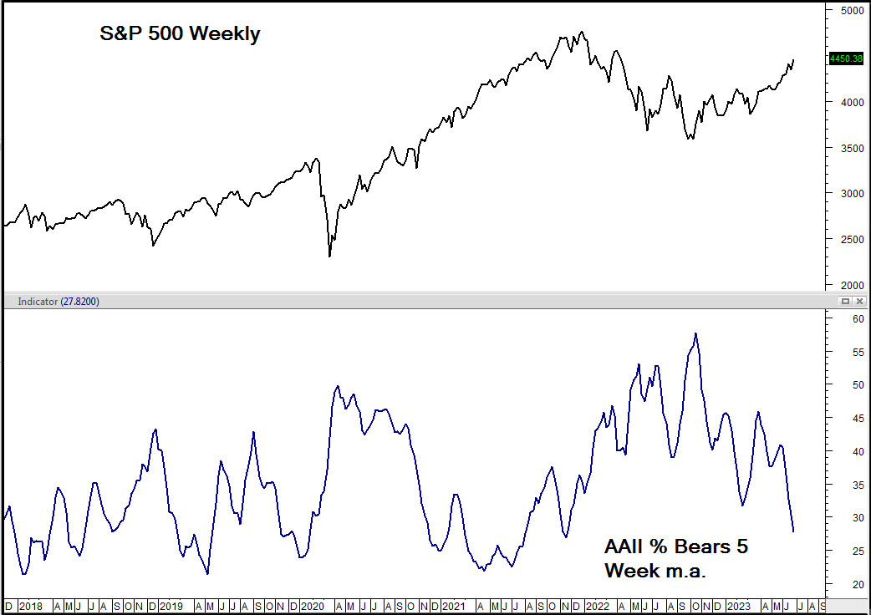

THE PUT CALL RATIO IS BEARISH.
It shouldn't come as a surprise that as the market has continued to rally that option buyers would start favoring calls over puts. Since call buying is at recent extremes, we could get a pullback at any time.
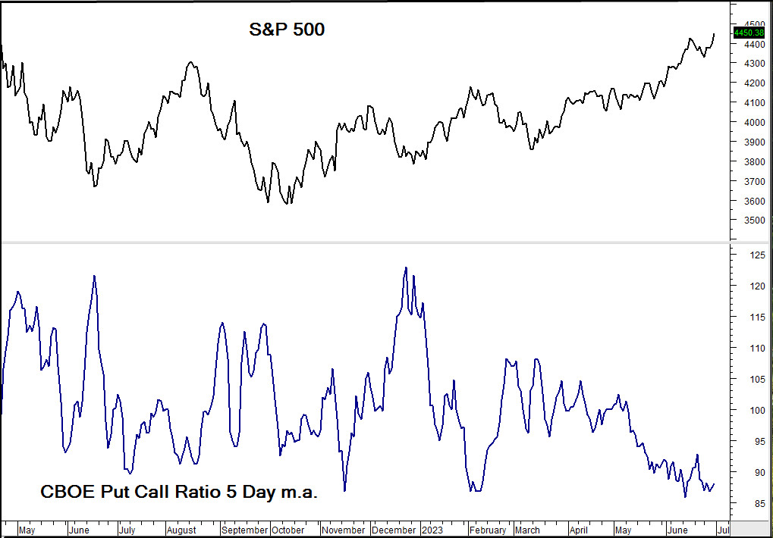

GOLD
Gold is in a significant resistance zone on the monthly chart. We think further upside progress will be difficult from current levels.
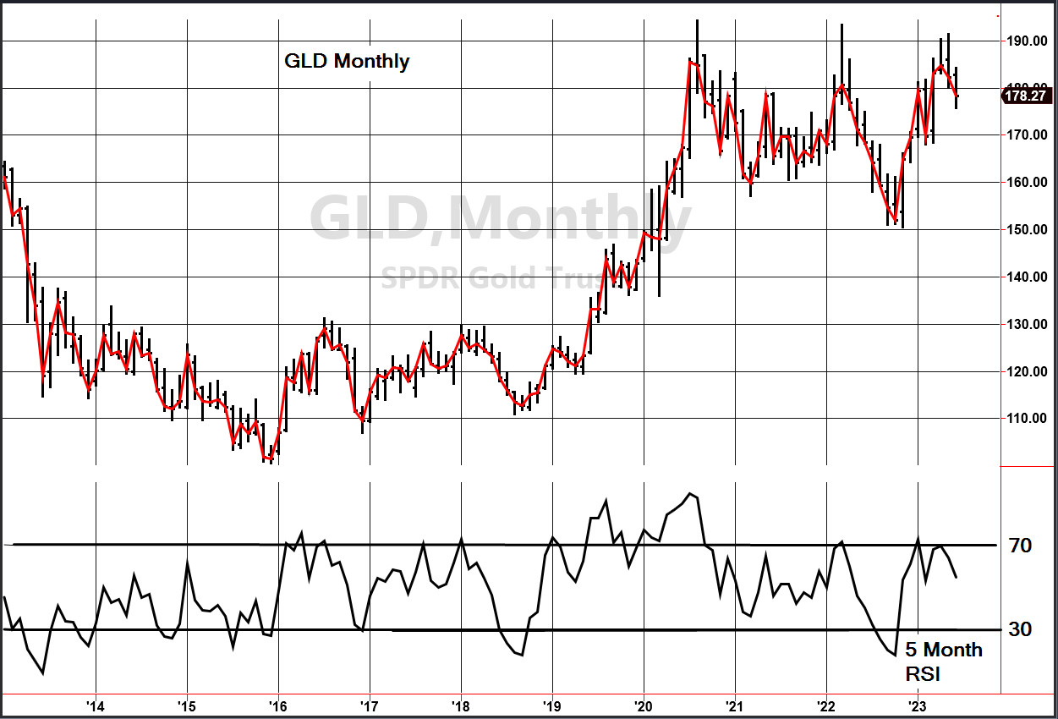

INTEREST RATES
The most widely watched measure of interest rates is the 10 year note and its interest rate or yield has been rising lately. But the market has rallied in spite of this.
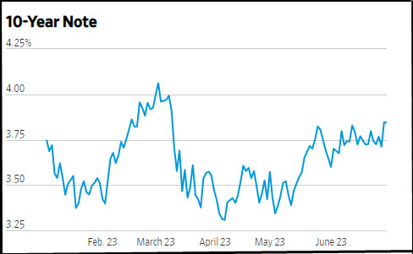

CANADIAN MARKETS
We're currently bullish on Canada after briefly flirting with the bearish side. The TSE 300 is just coming off an oversold 5 week RSI.
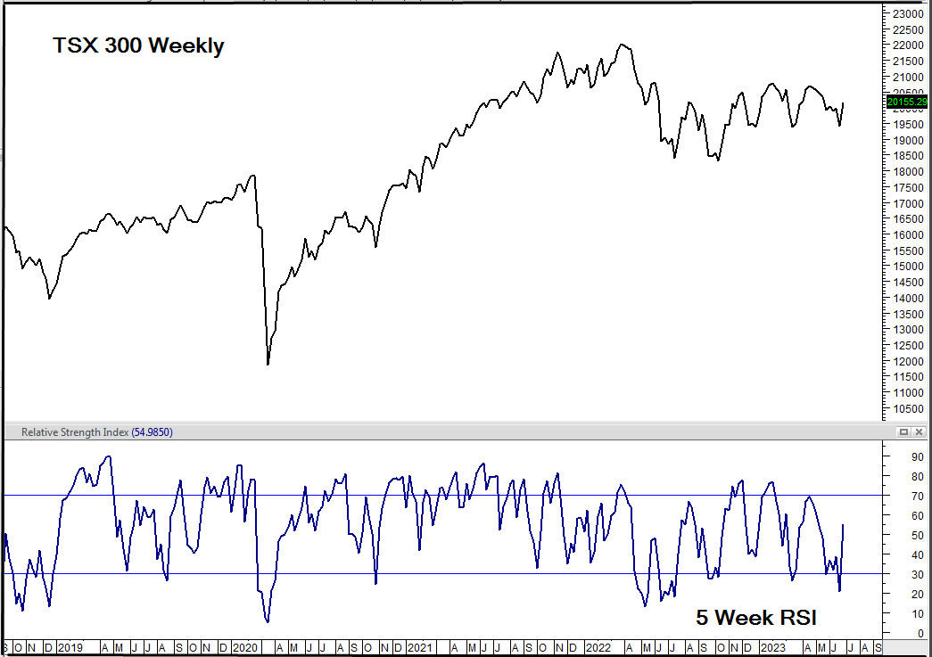

TRACK RECORD (TRADING)
We had one closed trade in June for a gain of 3.02. We are currently on the sidelines.
From December 31, 2010 through last Friday, the S&P 500 rallied 3192 points or 254 %. Our trading recommendations have resulted in a gain of 247.625 SSO points or 516 %. This is over twice the performance of the benchmark. The chart shows the comparison Since early 2019.
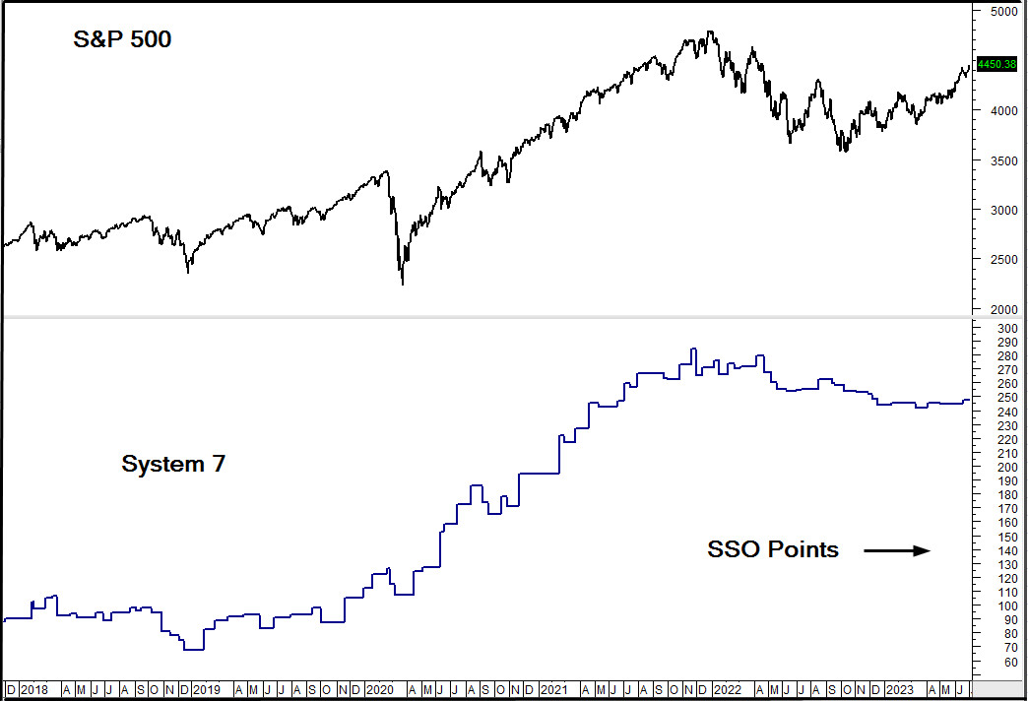
.
FINAL THOUGHTS
The next three months, July, August and September are historically the weakest for the market. We wouldn't be shocked by some consolidation, especially since so many erstwhile bears are now bullish. But, we intend to use any weakness for additional purchases.
We note that our stocks, Apple, Microsoft and Nvidia are either at or close to all time highs. Not bad for a weathering a bear market. We are on the lookout for further additions.

SPEAKING ENGAGEMENTS
If your group needs a speaker on the stock market give our office a call at 909 338 8354

END OF LETTER

